**PEACHY PANDA**

Report submitted in partial fulfilment of the requirement for the

degree of

B.Tech.

In

###### Computer Science & Engineering

By

##### Sameer Saxena (2101640100230)

##### Shachi Sachan (2101640100240)

##### Sanya Patel (2101640100233)

##### Under the guidance of

##### (Ms.Neha Singh)

##### (Assistant Professor)

##### Project Id:22_CS_2A_14



Pranveer Singh Institute of Technology, Kanpur

Dr A P J A K Technical University

Lucknow

## DECLARATION

This is to certify that Report entitled “PEACHY PANDA”which is submitted by me in partial fulfilment of the requirement for the award of degree B.Tech. in Computer Science and Engineering to Pranveer Singh Institute of Technology, Kanpur Dr. A P J A K Technical University, Lucknow comprises only our own work and due acknowledgement has been made in the text to all other material used.

#### Date:

Sameer Saxena (2101640100230)

Shachi Sachan (2101640100240)

Sanya Patel (2101640100233)

## 

## 

## Certificate

This is to certify that Report entitled “PEACHY PANDA” which is submitted by Sameer Saxena (2101640100230), Shachi Sachan (2101640100240), Sanya Patel (2101640100233) in partial fulfilment of the requirement for the award of degree B.Tech. in Computer Science & Engineering to Pranveer Singh Institute of Technology, Kanpur affiliated to Dr. A P J A K Technical University, Lucknow is a record of the candidate own work carried out by him under my supervision. The matter embodied in this thesis is original and has not been submitted for the award of any other degree.

| Signature:     Dr. Vishal Nagar  Dean CSE Department,  PSIT, Kanpur |  | Signature:  Name of Supervisor  Designation  CSE Department,  PSIT, Kanpur |
| --- | --- | --- |
|  |  |  |

***ACKNOWLEDGEMENT***

*It gives us a great sense of pleasure to present the report of the B.Tech. Project undertaken during B.Tech. Second Year. We owe special debt of gratitude to our project supervisor Ms.Neha Singh (Assistant Professor), Department of Computer Science and Engineering, Pranveer Singh Institute of Technology, Kanpur for her constant support and guidance throughout the course of our work. Her sincerely, thoroughness and perseverance have been a constant source of inspiration for us. It is only her cognizant efforts that our endeavours have seen light of the day.*

*We also take the opportunity to acknowledge the contribution of Professor Dr. Vishal Nagar, Dean Computer Science & Engineering Department, Pranveer Singh Institute of Technology, Kanpur for his full support and assistance during the development of the project.*

*We also do not like to miss the opportunity to acknowledge the contribution of all faculty members of the department for their kind assistance and cooperation during the development of our project. Last but not the least, we acknowledge our friends for their contribution in the completion of the project.*

*Signature: Signature:*

*Name:Sameer Saxena Name:Sanya Patel*

*Roll No.2101640100230 Roll No.2101640100233*

*Signature:*

*Name:Shachi Sachan*

*Roll No.2101640100240*

***ABSTRACT***

**Reason**

An e-commerce website is an online platform that enables customers to buy and sell products and services.It provides a convenient and accessible way for consumers to shop from the comfort of their own homes.E-commerce websites offer a wide variety of products and services, ranging from electronics and fashion to travel and hospitality.They often feature secure payment methods and user-friendly interfaces to ensure a seamless shopping experience for customers.E-commerce websites have revolutionized the way people shop, making it easier, faster, and more convenient than ever before.

An e-commerce website that also provides freelancing services can offer several benefits to both buyers and sellers. Firstly, it provides buyers with access to a wider pool of skilled professionals, allowing them to find the right freelancer for their specific project needs. Secondly, it offers freelancers with the opportunity to showcase their skills and work with a diverse range of clients, expanding their professional network and potentially increasing their earning potential.

By integrating freelancing services into an e-commerce website, the platform can also provide a seamless and convenient experience for both parties. Buyers can easily post job listings, review proposals, and communicate with freelancers through the platform, while freelancers can manage their projects, submit their work, and receive payment all in one place. This can help to streamline the entire process, saving time and effort for both parties.

In addition, an e-commerce website that also provides freelancing services can offer additional value to customers by providing them with a one-stop-shop for all their business needs. They can purchase products and services, as well as access skilled professionals for their projects, all on the same platform. This can save them time and effort in searching for different providers for different needs.

Overall, an e-commerce website that also provides freelancing services can offer a convenient and efficient solution for both buyers and sellers, providing access to a wider network of opportunities and streamlining the entire process.

**Main Findings**

Our e-commerce website offers a seamless shopping experience, allowing customers to browse and purchase a wide range of products from the comfort of their own homes. With a user-friendly interface and secure payment options, our website ensures a hassle-free shopping experience for all customers. We offer a diverse selection of products, ranging from electronics and household appliances to fashion and beauty products, all at competitive prices. Our website also features customer reviews and ratings, allowing shoppers to make informed purchasing decisions. With fast and reliable shipping and a dedicated customer support team, our e-commerce website is the ultimate destination for convenient and stress-free online shopping of skins and layers of various devices.

Our e-commerce website offers an exciting rewards program that grants customers 1 point for every 7 rupees spent on any of our products. These points can be accumulated and redeemed for a variety of benefits, including discounts on future purchases, free products, and more. Our program is designed to reward loyal customers and provide them with added value for their purchases, making our website the go-to destination for all their shopping needs. Shop now and start earning points today!

**TABLE OF CONTENTS**

**TITLE PAGE NO.**

1)Cover and Title Page 1

2)Declaration 2

3)Certificate 3

4)Acknowledgements 4

5)Abstract 5

**CHAPTER 1** (INTRODUCTION) 8

1.1 MOTIVATION 8

1.2 BACKGROUND OF PROBLEM 9

1.2.1 CURRENT SYSTEM 9

1.2.2 ISSUES IN CURRENT SYSTEM 9

1.2.1 FUNCTIONALITY ISSUES 10

1.3 PROBLEM STATEMENT 10

1.4 PROPOSED WORK 11

**CHAPTER 2**(DESIGN METHODOLOGY) 12

**CHAPTER 3** (IMPLEMENTATION) 14

**CHAPTER 4** (TESTING/RESULT AND ANALYSIS) 16

**CHAPTER 5** (CONCLUSION AND FUTURE ENHANCEMENTS) 19

**REFERENCES** 21

**CHAPTER 1: INTRODUCTION**

E-commerce websites have transformed the way people buy and sell products and services. These websites enable customers to shop from the comfort of their own homes, offering a wide range of products and services, including electronics, fashion, travel, and more. With the increasing prevalence of online shopping, e-commerce websites have become a crucial part of many businesses' operations, providing them with a platform to reach a wider audience and increase sales.

E-commerce websites offer several benefits to customers, including the convenience of 24/7 access, user-friendly interfaces, and secure payment methods. They also provide businesses with the opportunity to reduce overhead costs and increase profitability by eliminating the need for physical storefronts and reducing staffing requirements.

As the demand for online shopping continues to grow, e-commerce websites are constantly evolving, offering new features and technologies to enhance the customer experience. These include mobile optimization, personalized recommendations, and social media integration, among others. Overall, e-commerce websites have revolutionized the way people shop, making it easier, faster, and more convenient than ever before.

* 1. **MOTIVATION**

The main motivation for this project was to provide better customer satisfaction by giving them exciting offers and the opportunity to freelance. Building an e-commerce website can be a highly motivating endeavor for several reasons. Firstly, it provides the opportunity to create a digital platform that can potentially reach a wide audience and generate significant revenue. This can be particularly exciting for entrepreneurs and business owners looking to expand their customer base and increase profitability.

Secondly, an e-commerce website allows for the creation of a unique brand identity and the development of a loyal customer base. By providing customers with a seamless and enjoyable shopping experience, businesses can build a reputation for quality and reliability, which can help to drive repeat business and positive word-of-mouth referrals.

* 1. **BACKGROUND OF PROBLEM**

The e-commerce websites can face several problems that can hinder its growth and profitability. E-commerce websites that do not offer freelancing services may be limited in terms of their capabilities and flexibility, which could impact their ability to compete in the market and provide the best possible experience for customers. It is important for businesses to consider the potential advantages of offering freelancing services and to develop strategies to integrate these services into their e-commerce platforms where feasible.

**Current System**

* + 1. **Issues in Current System**

E-commerce websites without freelancing options can also have some disadvantages, including:

* Limited services: E-commerce websites that do not offer freelancing services may be limited in terms of the range of products and services they can offer to customers, as they may not have access to a wider pool of skilled workers.
* Reduced flexibility: E-commerce websites that do not offer freelancing services may be less flexible in terms of offering customized or personalized services to customers, as they may not have access to a wide range of specialized skills and expertise.
* Higher costs: E-commerce websites that do not offer freelancing services may need to hire in-house staff to perform certain tasks, which can be more expensive than outsourcing those tasks to freelancers.
* Limited expertise: E-commerce websites that do not offer freelancing services may be limited in terms of their ability to provide specialized expertise or knowledge to customers, which could impact their credibility and reputation in the market.
* Limited innovation: E-commerce websites that do not offer freelancing services may be limited in their ability to innovate and develop new products or services, as they may not have access to the latest trends and technologies in the market.

**1.2.2.1 Functionality Issues**

1. Limited customer engagement: Without a reward system, the website may struggle to engage customers and encourage repeat purchases, leading to reduced revenue and customer loyalty.
2. Reduced traffic and sales: The absence of a reward system may also impact the website's ability to attract new customers and generate sales, as there may be less incentive for customers to shop on the website.
3. Limited service offerings: Without freelancing options, the website may be limited in terms of the services and products it can offer to customers, which may impact its competitiveness in the market.
4. Reduced flexibility and customization: The website may also be less flexible in terms of offering customized or personalized services to customers, which could impact customer satisfaction and retention.
5. Lack of innovation: Without a reward system and freelancing options, the website may be limited in terms of its ability to innovate and develop new products or services, which could impact its long-term growth and success.
   1. **PROBLEM STATEMENT**

Despite the growth in online shopping, many businesses struggle to establish a successful e-commerce presence due to a range of challenges, including intense competition, complex regulatory frameworks, and evolving customer preferences. These challenges can impact the website's functionality, customer engagement, and revenue growth, making it difficult for businesses to achieve long-term success in the e-commerce market. As such, there is a need for e-commerce websites to develop strategies that mitigate these challenges and optimize their capabilities to provide a seamless shopping experience for customers and drive sustainable growth for the business.

**1.4 Proposed Work**

An e-commerce website with exciting offers and freelance options could provide a range of benefits for businesses and customers alike. By offering exciting discounts and promotions, the website could attract new customers and encourage repeat purchases, driving revenue growth and customer loyalty. Additionally, by integrating freelance options into the platform, the website could expand its service offerings, access a wider pool of skilled workers, and provide more customized and personalized services to customers. Typically the strategies to overcome the issues faced by an e commerce website can be as follows:

1.Freelancing

Our e-commerce website that also provides freelancing services can offer additional value to customers by providing them with a one-stop-shop for all their business needs. They can purchase products and services, as well as access a better market for their projects, all on the same platform. This can save them time and effort in searching for different providers for different needs.Overall, an e-commerce website that also provides freelancing services can offer a convenient and efficient solution for both buyers and sellers, providing access to a wider network of opportunities and streamlining the entire process.

2.Rewards

Our e-commerce website offers an exciting rewards program that grants customers 1 point for every 7 rupees spent on any of our products. These points can be accumulated and redeemed for a variety of benefits, including discounts on future purchases, free products, and more. Our program is designed to reward loyal customers and provide them with added value for their purchases, making our website the go-to destination for all their shopping needs. .

**CHAPTER 2:DESIGN METHODOLOGY**

Module 1: The “Home” page would contain all the necessary information for the customers-

1) My Account

2) Designs

3) Upload Yours

4) Rewards

5) Customer Service

Module 2: “My Account” page would firstly consist of user's personal information such as name, address , phone number, pin code

Module 3: The “Designs” page would consist of variety of designs for electronic gadgets.

Module 4: The “Upload Yours” page would allow the customer to uplaod his design on the website.

Module 5: The “Rewards” section would show the orders placed by the user and the points earned by the orders(where ₹7=1point ).Also this section would show the total uploads done by the user along with the points earned.

Module 6: “Customer Service” section would allow customers to rate our website and provide their reviews. Also they can also post their queries regarding related to our website.

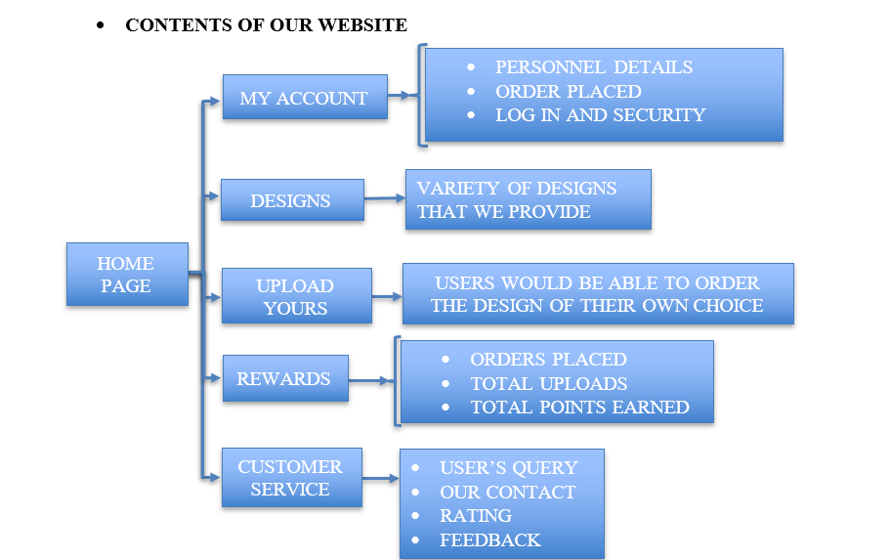

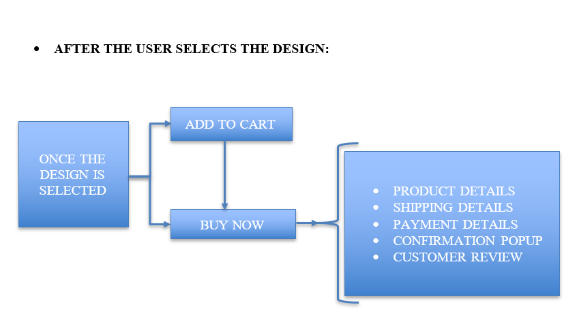

**CHAPTER 3:Implementation**

**3.1 HTML**

HTML (Hypertext Markup Language) is a markup language used for creating web pages and other types of documents that can be displayed in a web browser. It consists of a series of tags and attributes that define the structure and content of a document, including text, images, links, and other media.HTML provides a standardized way of organizing and presenting information on the web, allowing web developers to create structured documents that can be easily interpreted and displayed by web browsers. It is a simple, straightforward language that can be learned and used by anyone with basic coding knowledge.

HTML has evolved over time to include new features and capabilities, such as the ability to embed multimedia content, create interactive forms, and incorporate dynamic scripting languages such as JavaScript. While HTML is typically used in conjunction with other programming languages and technologies to create fully functional web applications, it remains a fundamental building block of the web and a critical component of modern web development.

**3.2 CSS**

CSS (Cascading Style Sheets) is a style sheet language used for describing the presentation and layout of web pages written in HTML or XML. CSS allows web developers to separate the content of a web page from its presentation, providing greater flexibility and control over the design and layout of a website.With CSS, web developers can define the font, color, background, and layout of text and other elements on a web page, and create custom styles for different types of content. By creating a single set of CSS rules that apply to all pages on a website, developers can ensure consistency in the design and layout of a site, and make global changes to the appearance of a website without having to modify each individual page.CSS can be used to create complex, responsive layouts that adapt to different screen sizes and devices, making it an essential tool for creating modern, mobile-friendly websites. CSS also allows for the creation of custom animations and effects, allowing web developers to add interactivity and visual interest to their designs.

Overall, CSS is a powerful tool for web development that allows for greater control and flexibility in the presentation of web pages, helping to create engaging and visually appealing websites.

**3.3 JavaScript**

Some key features of JavaScript include its ability to manipulate the Document Object Model (DOM) of web pages, which allows developers to dynamically modify the content and structure of a web page in response to user interactions or other events. JavaScript also supports object-oriented programming principles, such as encapsulation, inheritance, and polymorphism.

In recent years, JavaScript has evolved significantly with the introduction of new language features such as async/await, arrow functions, and template literals, among others. Additionally, there are many popular frameworks and libraries built on top of JavaScript, such as React, Angular, and Vue.js, which make it easier to build complex web applications. Overall, JavaScript is a powerful and versatile programming language that continues to play a central role in web development and beyond.

**3.4 Python**

Python is a popular programming language for building the backend of e-commerce websites. It has a number of benefits that make it well-suited for this purpose such as Python is a scalable language, which means it can handle large amounts of traffic and data. This is important for e-commerce websites that may experience high traffic volumes during peak times, such as holidays or sales events.Python can easily integrate with popular databases like MySQL and PostgreSQL, which are commonly used to store and manage data for e-commerce websites.Python has a number of built-in security features, such as support for SSL encryption and secure user authentication, which are crucial for protecting sensitive customer data.Python is known for its clean syntax and readability, which makes it easy for developers to write and maintain code. This can save time and reduce the risk of errors in a complex e-commerce application.Python has a number of powerful web frameworks and libraries, such as Django and Flask, which provide pre-built functionality for common e-commerce features like shopping carts, payment processing, and user account management. Overall, Python's scalability, security, ease of use, and robust ecosystem of frameworks and libraries make it a great choice for building the backend of e-commerce websites.

**CHAPTER 4: TESTING/RESULT AND ANALYSIS**

The interface for PEACHY PANDA has been created. The screenshots of the pages of the website are as follows:

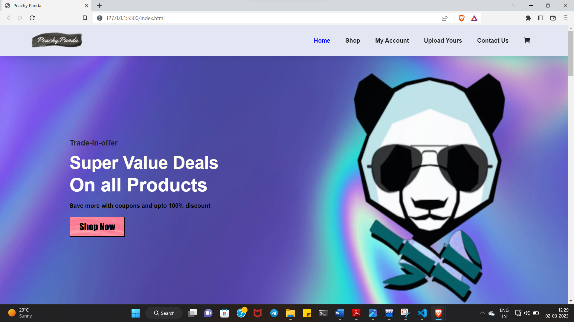

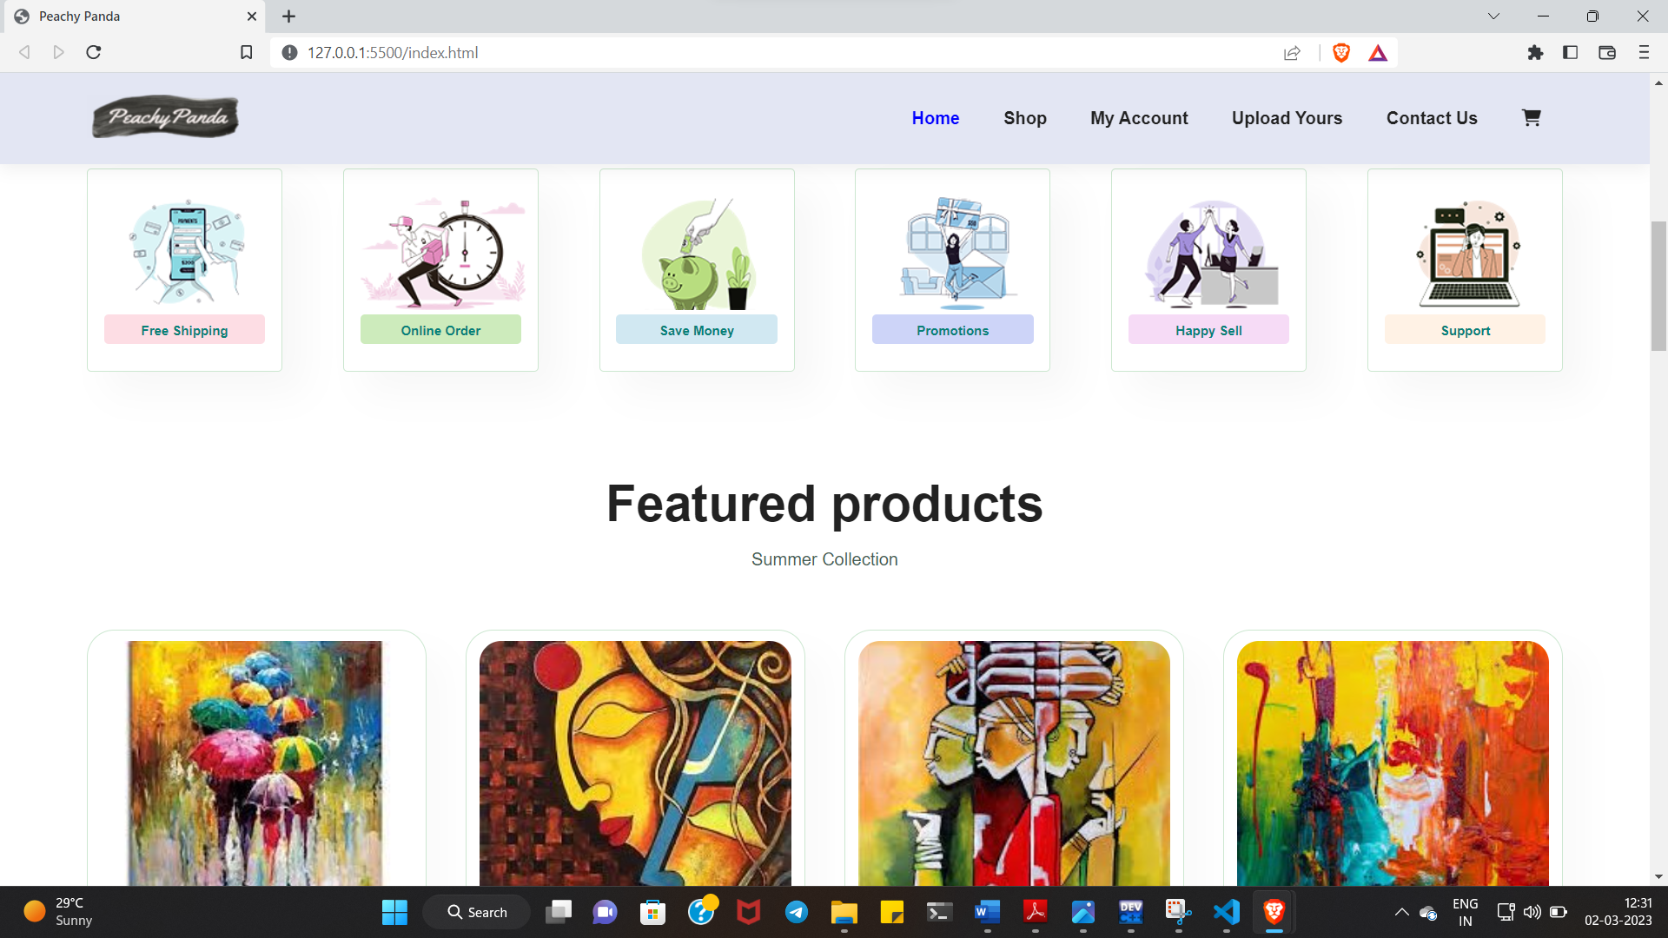

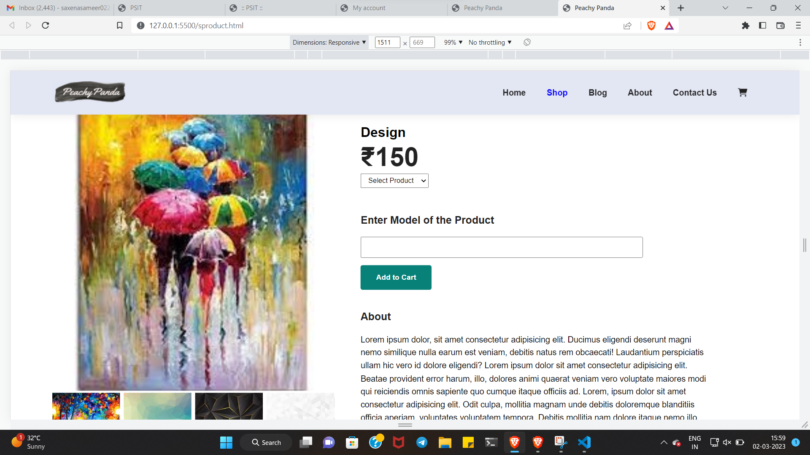

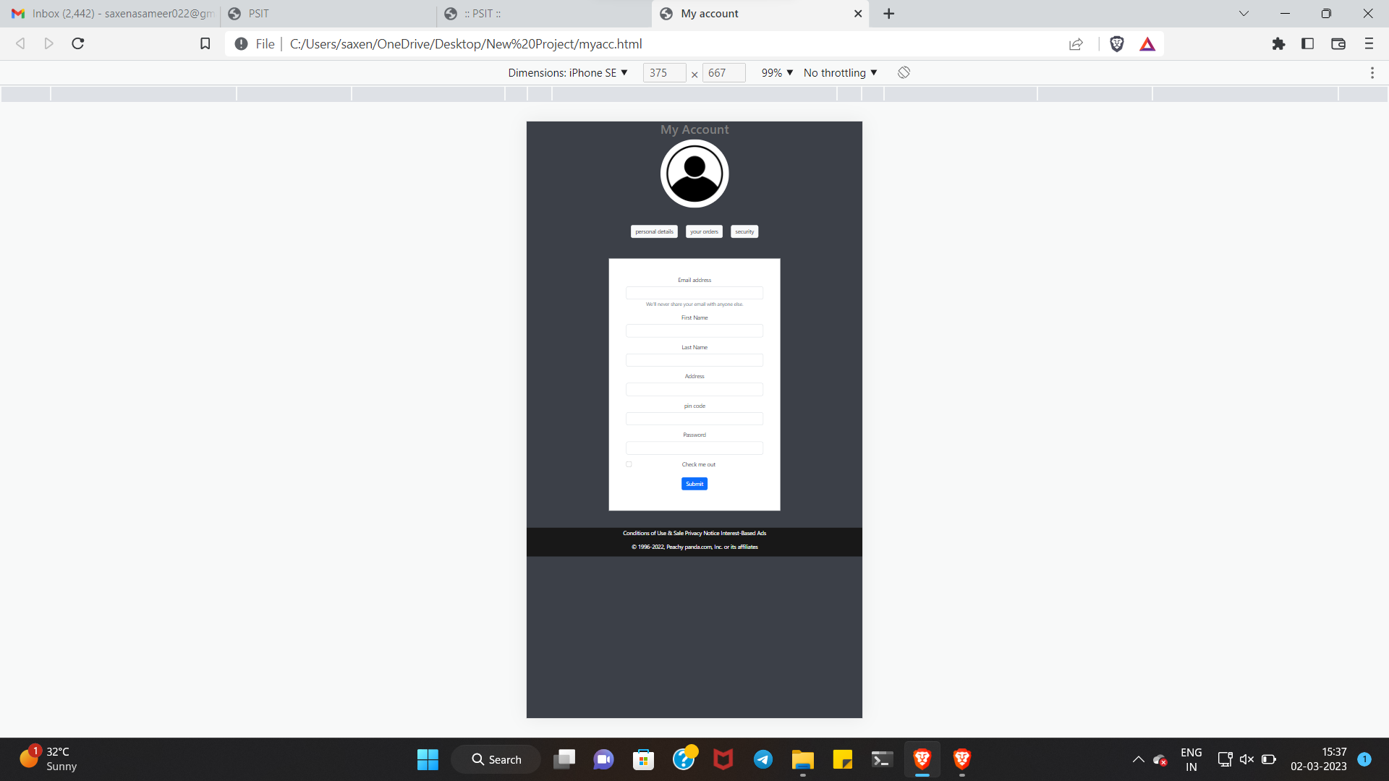

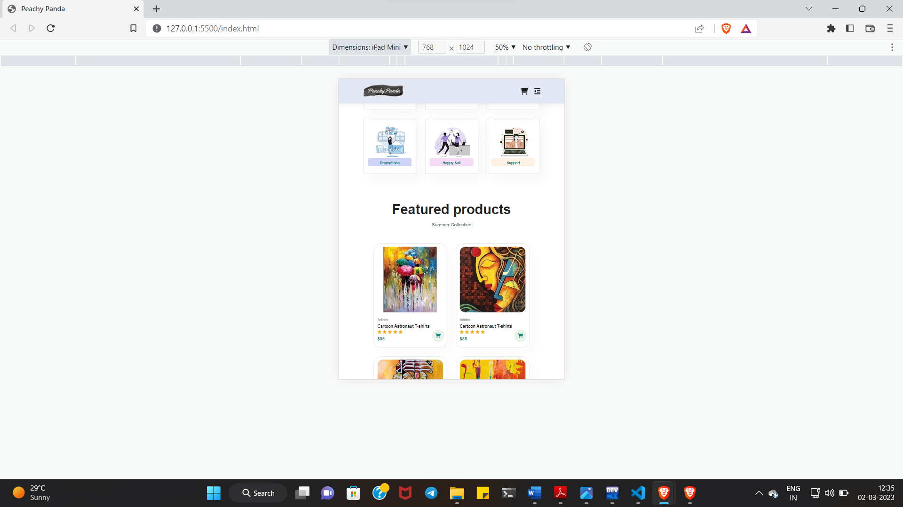

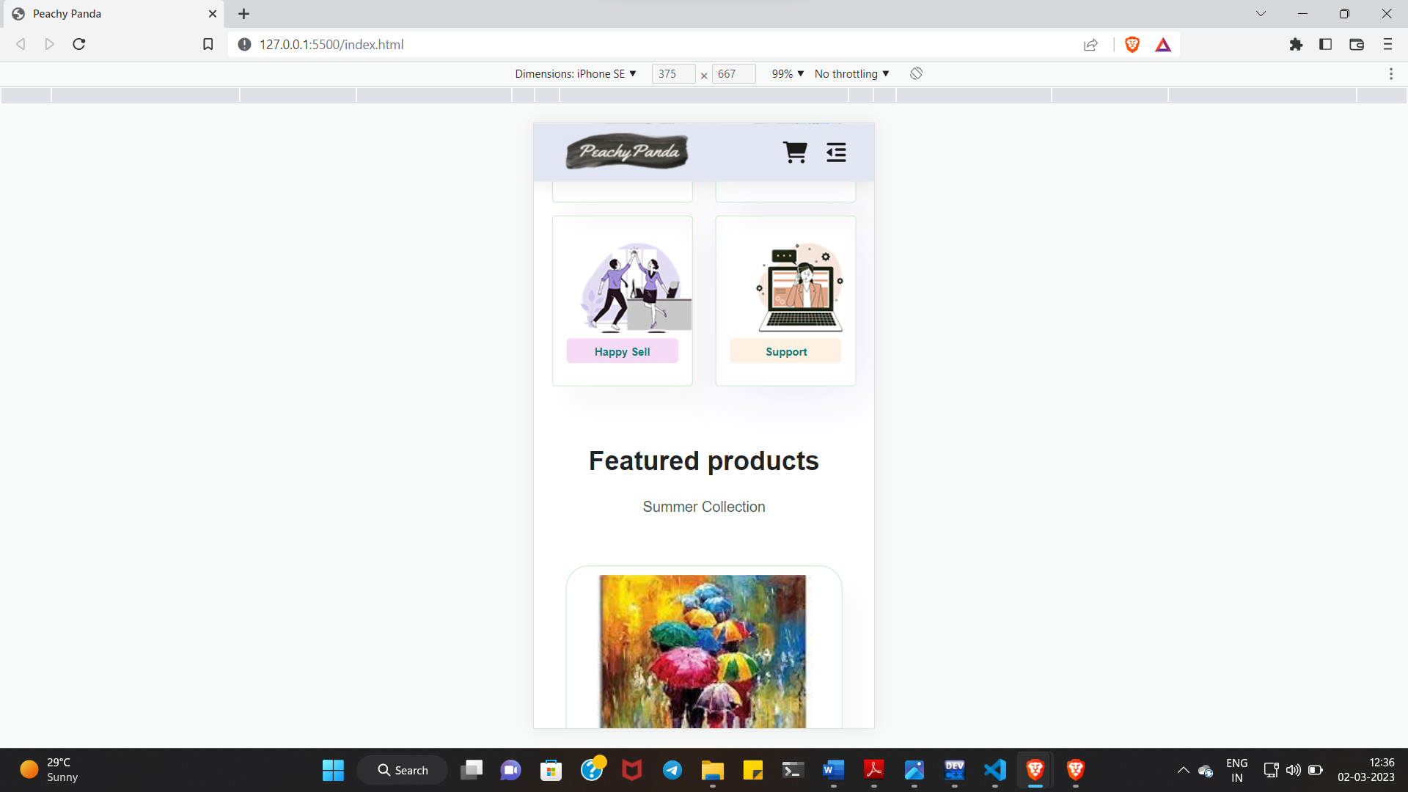

**CHAPTER 5: CONCLUSION AND FUTURE ENHANCEMENTS**

**5.1 Conclusion**

In conclusion, e-commerce websites have become a vital part of the modern retail landscape. They offer convenience, accessibility, and a wide variety of products to consumers around the world. The success of an e-commerce website depends on a number of factors, including website design, user experience, security, and backend technology.

A well-designed e-commerce website should have a user-friendly interface, intuitive navigation, and a seamless checkout process. It should also be secure, with strong measures in place to protect customer data and prevent fraud.

The backend technology of an e-commerce website is equally important, as it enables the website to handle high traffic volumes, process transactions, and manage inventory and shipping. Popular backend technologies for e-commerce websites include Python, which is known for its scalability, security, and ease of use.

Overall, the success of an e-commerce website depends on a combination of factors, including website design, user experience, security, and backend technology. By paying attention to these areas and investing in the right technology, e-commerce businesses can create a successful and profitable online presence.

**5.2 Future Enhancements**

There are many potential enhancements that could be made to an e-commerce website to improve its functionality, user experience, and overall success. Here are a few possibilities:

* Personalization: By using data analytics and machine learning, e-commerce websites can personalize the shopping experience for each user based on their browsing and purchase history. This could include personalized recommendations, targeted promotions, and customized product offerings.
* Augmented Reality (AR): AR technology can allow customers to see how products would look or fit in their own environment before making a purchase. This can improve customer satisfaction and reduce product returns.
* Voice search: With the growing popularity of smart speakers and voice assistants, integrating voice search capabilities into an e-commerce website could improve accessibility and convenience for customers.
* Chatbots: Chatbots can provide instant customer service support, answer questions, and guide customers through the purchasing process. This can improve customer satisfaction and reduce the workload for customer service representatives.
* Mobile optimization: With more and more consumers using mobile devices to shop online, it's important for e-commerce websites to be optimized for mobile browsing and purchasing. This could include responsive design, simplified navigation, and mobile payment options.

Overall, there are many potential enhancements that could be made to an e-commerce website to improve its functionality, user experience, and success. By staying up-to-date with the latest technology trends and investing in the right areas, e-commerce businesses can stay competitive and succeed in a rapidly evolving market.

**REFERENCES**

1. Google
2. [www.youtube.com](http://www.youtube.com)
3. <https://www.github.com>
4. [www.geeksforgeeks.com](http://www.geeksforgeeks.com)
5. Wikipedia